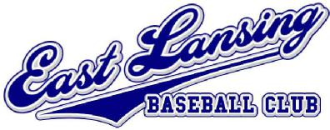 | East Lansing U11 Classic July 17-19, 2015

Location: Patriarche Park, East Lansing, MI 48823

Date: July 17-19, 2015
Age Divisions: U11 (Community-based Teams Only*)
Age cut-off: May 1st. Fee: $385 per team (Roster limited to 14 players)
Three games per team guaranteed (weather permitting) 1st & 2nd place teams receive individual trophies
Team Level: *U11 Community-based teams only. All players must be from the same community or school district.
Entry Deadline: Registrations due by June 30, 2015. Insurance certificate required. Limited space
is available. Rosters and Insurance may be submitted by email.
Contact: Mike McCune, mikemccune2@gmail.com
Please enclose this registration form along with a check payable to:
East Lansing Baseball Club (c/o: Mike McCune)
811 Collingwood Drive
East Lansing, MI 48823
East Lansing Tournament Registration
Team Name: Age Group: U11
Coach’s Name: ___________________________________________________
Address:
City: State: Zip:
Phone#:___________________________ Email: ______________________________________________________
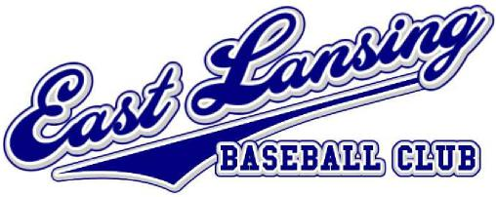
East Lansing U11 Classic
Player Roster
TEAM NAME:______________________________________ AGE GROUP: U11
COACHES SIGNATURE:
PLAYER’S NAME BIRTHDATE STREET ADDRESS/CITY SCHOOL DISTRICT

